# 

# 

# 

# PATAN COLLEGE FOR PROFESSIONAL STUDIES

# Individual Reflective Report

# 

# 

# 

# Ujaalo Student Information Kiosk

# PROJECT REPORT

# Submitted by Submitted to

# Kshitij Bajagain (1723333) UOB

# 

**Individual Reflective Report**

This form is submitted by every member of your group and used to assess the level of teamwork in your group and the contribution of individuals. It may also form the basis of discussions which affect the grades received by individual group members.

|  |  |  |  |
| --- | --- | --- | --- |
| Student Number | First Name | Last Name | Group No |
| 1723333 | Kshitij | Bajagain | 1 |

Programming has always been my passion and as I have already engaged in the software development in previous semesters as a developer successfully. So, I was totally motivated and excited to get engage in development of new software for this semester too. University of Bedfordshire has given us the assignment of developing Student Information Kiosk Software in Level – 5 Semester II. Student Information Kiosk will help the student as well as normal people by making them aware of events occurring in both inside campus premises and within community. Along with Student Information Kiosk will help students and people to know detail information regarding University and its campuses.

As this assignment is group assignment choosing a group is always challenging. Working in a team is always an experience for me. I was in dilemma if I can work efficiently or not but working with team members (Lokendra Dangi, Buddha Lama, Prabin Chapagain and Prajwol Thapa) made the work easy and smooth. We sliced the work into equal portion for every team members in every sector of development. Proper coordination routinely scheduled and equal division of work is the key for the development of this software. Every group

There was little confusion while initial phase of development but because of proper coordination and contribution, difficulties regarding development was over. In group report we have mentioned our group organization role along with this we have attested work division and work plan. We followed agile methodology for development of this kiosk software. Work division is shown below with individual members contribution followed during the whole software development cycle.

**Work Division**

|  |  |  |  |
| --- | --- | --- | --- |
| **S. N.** | **Name** | **GUI &**  **Implementation** | **Diagrams &**  **Documentation** |
| 1 | Kshitij Bajagain | Student Dashboard , Events & Booking, My/All Booking , Account Details ,Clubs , Admin Dashboard design and their functionalities | ER Diagram, Class Diagram, Design and implementation, work division. |
| 2 | Lokendra Dangi | Add Events , Alter Events , Update Events, Delete Events design and their functionalities | UseCase Diagram, Class Diagram, Introduction of report, Testing part. |
| 3 | Buddha Lama | Register Page , Login Page , Why Us , Help, Brochure, Accommodation , User Information(admin) design and their functionalities | Sequence Diagram, Class Diagram. Project plan. |
| 4 | Prabin Chapagain | Browser Functionality , Campuses (Luton, Bedford, Aylesbury, Milton Keynes, Putter ridge , Patan College) ,Education Loan | Activity Diagram, Class Diagram, agile and primary research. |
| 5 | Prajwol Thapa | Splash Screen , Kiosk Main Home Courses(Undergraduate , graduate , Foundation and International Students) , Invoice Generation | Sequence Diagram, Class Diagram, aims and objectives and critical analysis. |

Every team member has contributed according work division mentioned above. I worked and contributed my portion during the whole software development phase according above work division only. My work with screenshots along with code snippets are mentioned in my contribution part of this individual reflective report.

**Evaluation**

In group, every team members worked according to the work plan and division. Proper co-ordination with team members successfully us to develop this functional kiosk. Evaluation of team members is shown below:

|  |  |  |  |
| --- | --- | --- | --- |
| Student Number | First Name | Last Name | Contribution  (N,S,I) |
| 1723936 | Buddha | Lama | S |
| 1720849 | Lokendra | Dangi | S |
| 1721484 | Prabin | Chapagain | S |
| 1721479 | Prajwol | Thapa | S |

**S** -Significant (The group member’s work was integral to the overall submission)

**N** -No Contribution (The group member took no part in the project submission)

**I** -Insignificant (The group member’s work made little difference to the overall submission)

Conclusion:

It was a great opportunity for me to work with team members. Co-ordination and equal contribution is the key for the project development, this statement is the main core knowledge which I learned during this whole development cycle. There were many confusion during initial phase of development but as I mentioned already team members boosted me to complete my work in time.

I am feeling so much proud that my group successfully developed this Ujaalo Student Information Kiosk. .It was great opportunity and experience while working with team-members (Buddha Lama, Lokendra Dangi, Prabin Chapagain, and Prajwol Thapa) during software development. At last I would like show gratitude towards my team members, Faculty Bishwo Kiran Bhhatari, HOD Dr. Swati Shah, Er. Ajaya Sharma and especially my parents for motivating and helping me to accomplish this software development.

**My Contribution Snippets:**

**Following snippets are my contribution as mentioned in work division which I did during software development:-**

1. **UML Diagrams(Entity Relationship Diagram):**

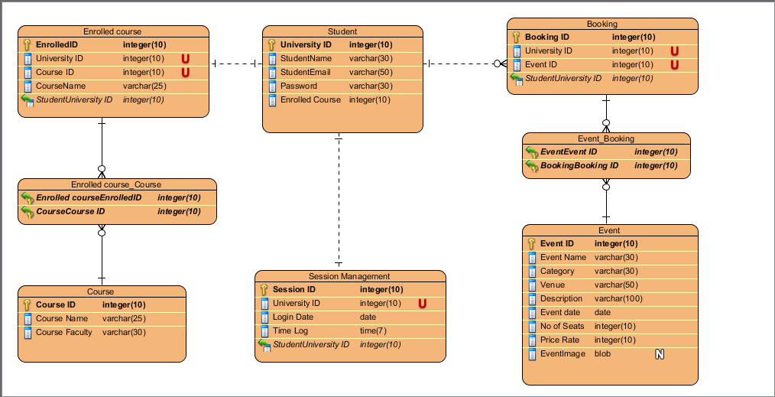

Fig: - Ujaalo Student Information Kiosk Activity Diagram

1. **GUI and Implementation of Software which I did:**

These are the functions that I have did during software development

1. Student Dashboard:

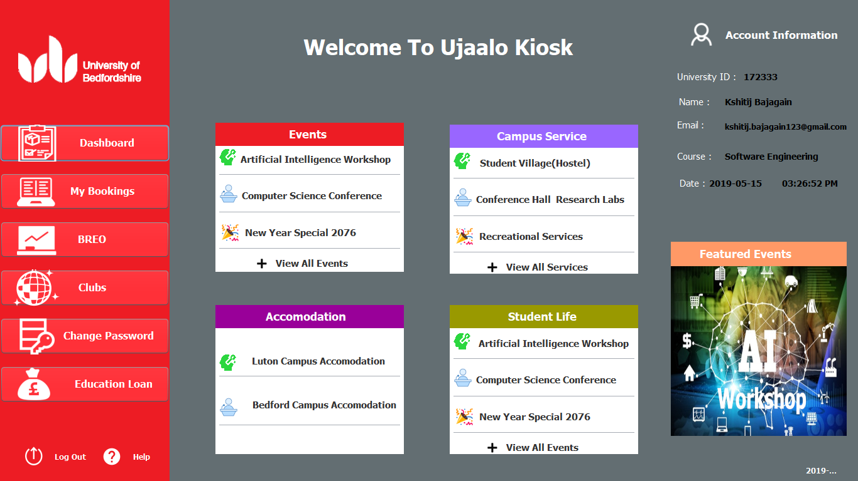

1. Student My Booking:

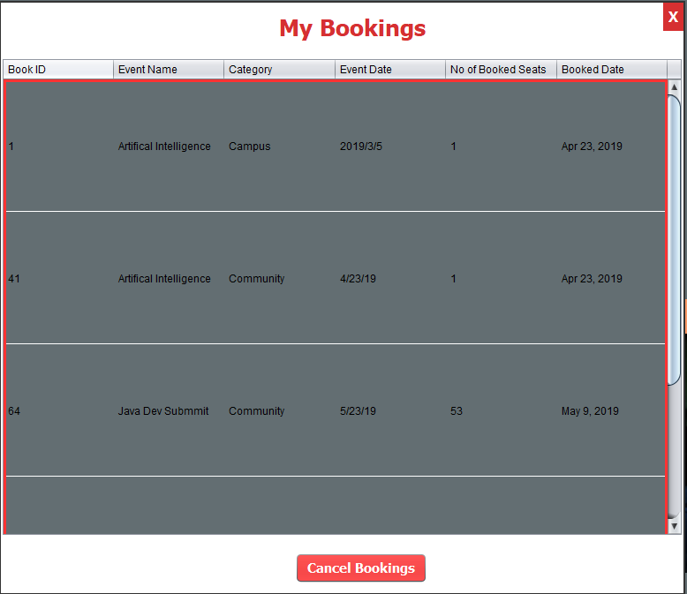

1. Clubs:

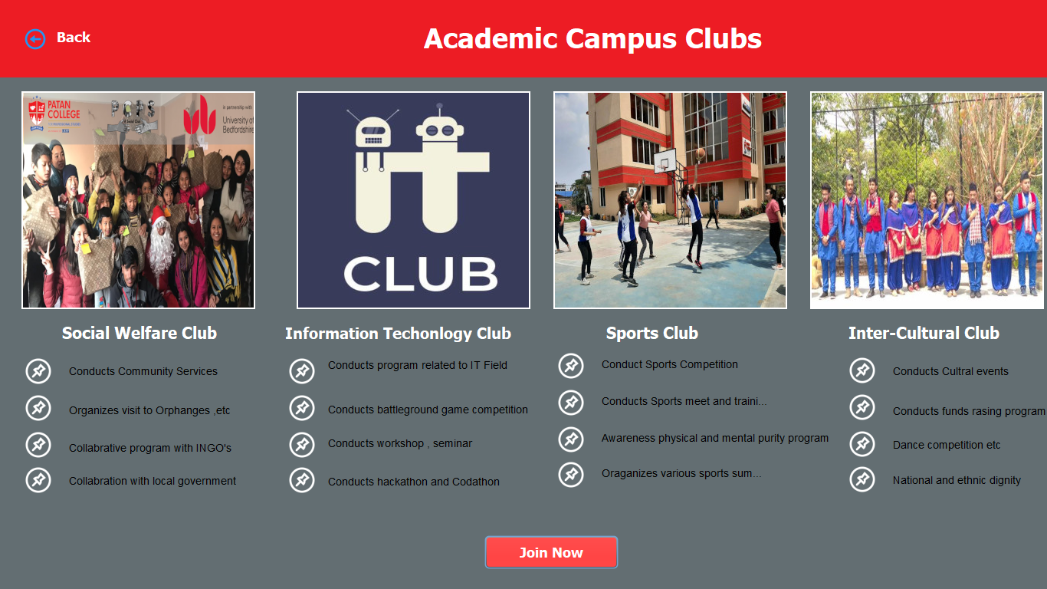

1. Change Password

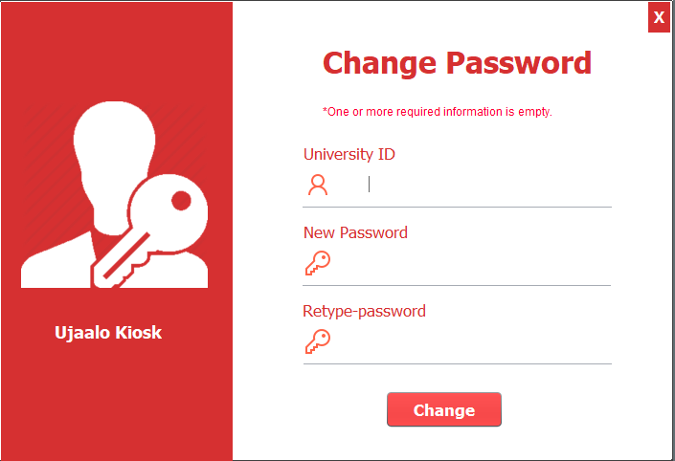

e> Events and Booking:

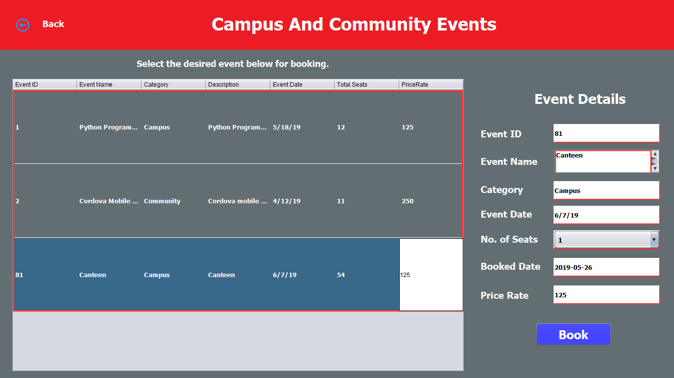

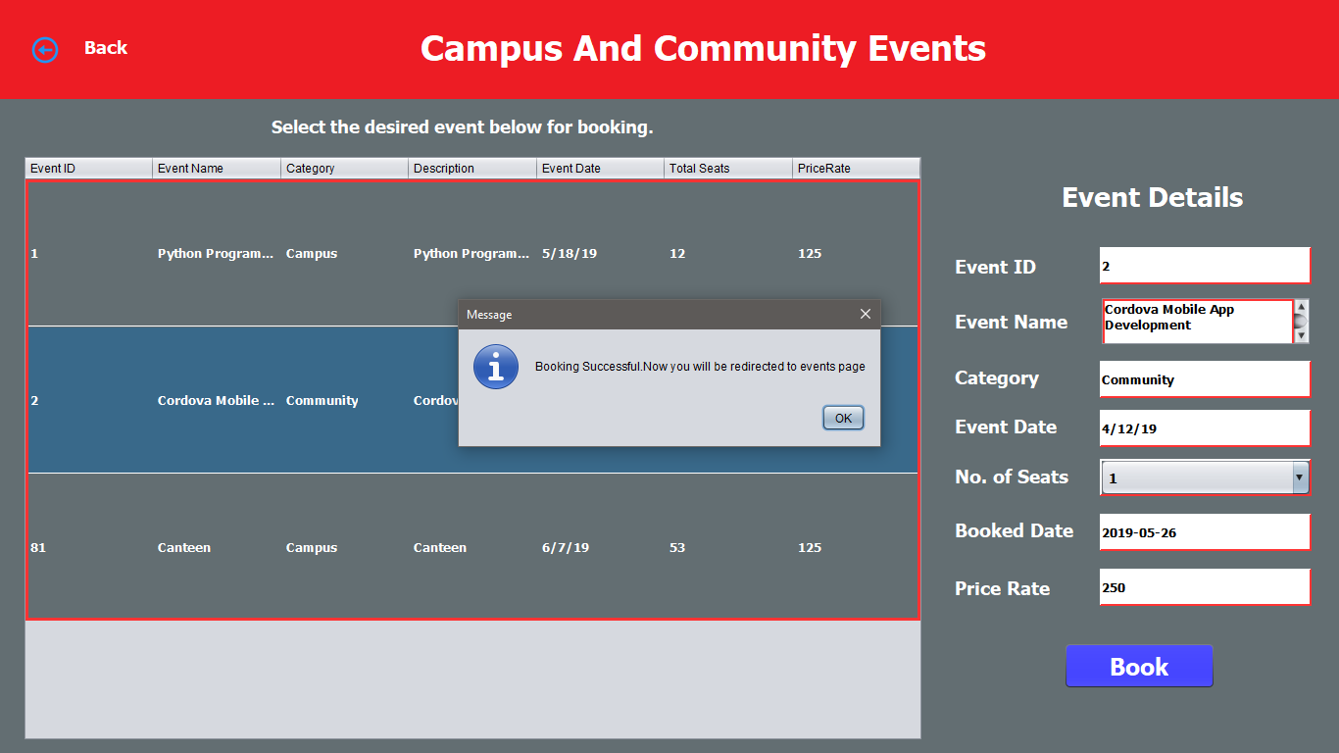

f>BREO functionalities:

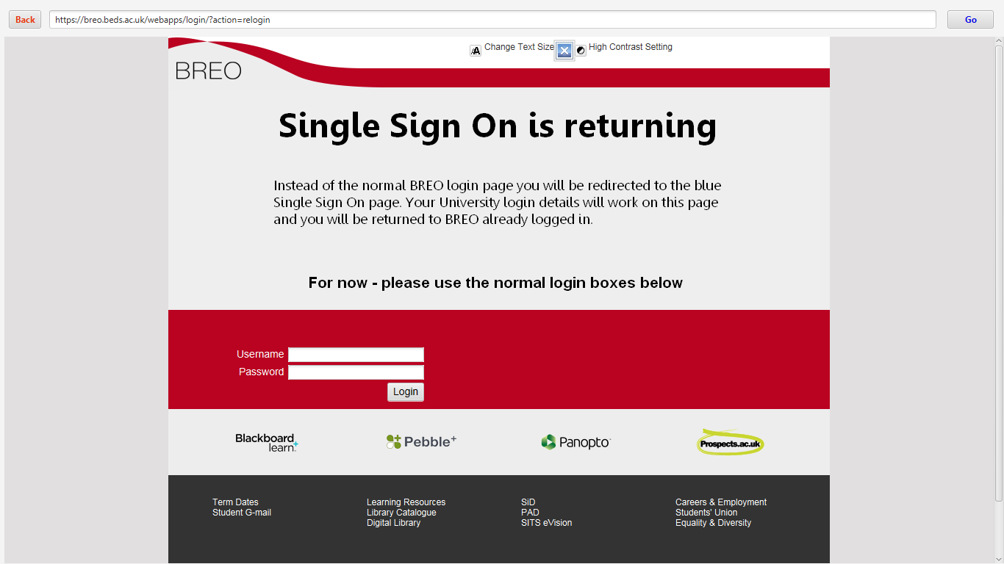

g> Admin Dashboard:

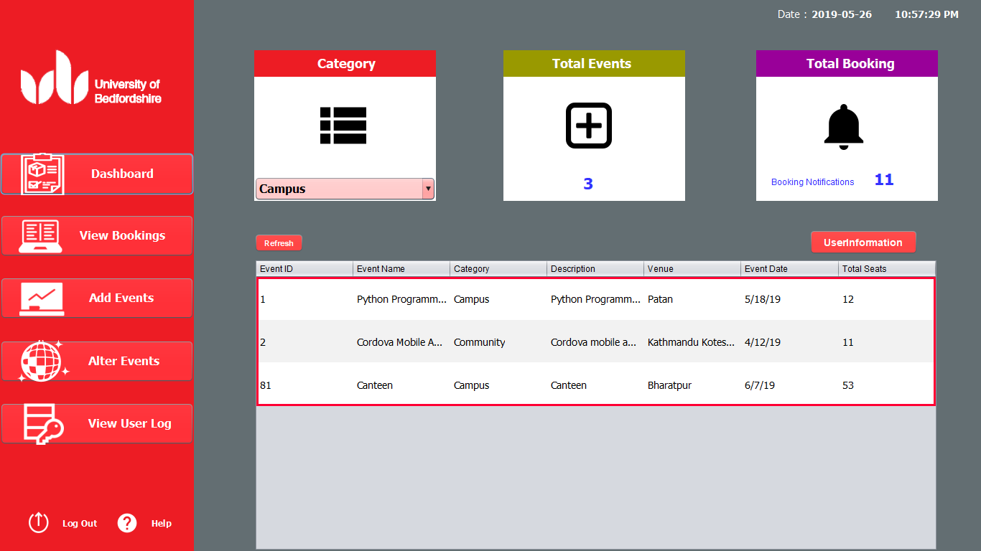

h> View all Booking:

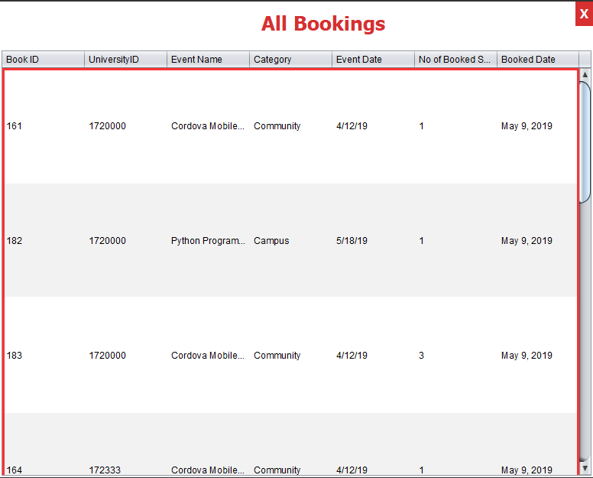

i>View User Log:

